1- A project description (Introduction, scope, similar products, requirments, features design etc)
The Car Rental System project is a web-based application developed using PHP and MySQL, designed to manage the rental process of vehicles. The system will serve as an informative website for customers to view available cars, rental terms, and pricing. The admin panel will be accessible only to authorized users (such as administrators) for managing the inventory, processing customer reservations, and maintaining data integrity.
This system aims to simplify the car rental process for both customers and administrators by providing a seamless interface for car selection, booking, and administrative functions such as adding, updating, and deleting vehicle records. The platform will also provide an overview of past rentals, customer feedback, and statistical reports to assist in the decision-making process.
The scope of this Car Rental System project encompasses the following core areas:
- User Interface for Customers: A customer-facing front-end where users can browse available cars, check availability, view car details, and make reservations online.
- Admin Panel: A back-end interface for administrators to manage the rental operations, including adding or removing cars, updating prices, and viewing reservations.
- Database Management: A robust MySQL database to store and manage information such as car details, rental prices, customer information, reservations, and rental history.
- Reservation System: Customers can select the type of car they wish to rent, enter their personal information, and book a car for a specific period. Admins can manage these reservations and confirm or cancel them.
The system will be accessible from any browser and will be designed to be mobile-friendly, ensuring a wide range of users can interact with the platform efficiently.
Some popular car rental platforms that serve as benchmarks for this project include:
- Enterprise Rent-A-Car: A global car rental service providing users with an online platform to search for and book cars.
- Hertz: Another leading car rental company with an online booking platform that allows customers to choose cars based on location, type, and rental duration.
- Avis: Known for its global car rental services, Avis offers a user-friendly interface for browsing car options and booking rentals online.
These platforms offer a similar set of features but differ in design and complexity. Our system aims to provide the core functionalities of these platforms, while simplifying the user interface for ease of use.
Functional Requirements:
- User Registration: Customers will be required to create an account to make reservations, though browsing the available cars may be available without login.
- Car Selection: Users can browse through a range of cars, filtered by various categories such as car type, model, and price.
- Online Reservation: Users can choose the desired car, set rental dates, and complete the booking with contact details.
- Admin Dashboard: An administrator will be able to manage car listings, review bookings, and generate rental reports. Admins will have access to all customer data, reservations, and historical records.
- Payment Integration (optional): The system may include an online payment feature where customers can pay for their rental bookings.
Non-Functional Requirements:
- User-friendly Interface: Both the customer-facing website and the admin panel should be easy to use with clear navigation.
- Mobile Responsiveness: The website will be designed to be fully responsive, ensuring usability on various devices, including smartphones and tablets.
- Security: The system must ensure secure storage and transmission of sensitive data such as customer details and reservation information. Encryption for password storage and secure login mechanisms will be essential.
- Scalability: The application should be built with scalability in mind, so it can handle a growing number of users and vehicles.
- Reliability: The system must be stable, with minimal downtime, ensuring smooth operations for both customers and administrators.
The Car Rental System will be designed with a focus on both simplicity and functionality. Below are the main features and design specifications:
Customer Features:
- Home Page: A welcoming homepage showcasing featured cars, rental promotions, and a search bar for quick vehicle search.
- Car Search & Filter: Customers can search for cars based on various parameters, including car type, model, price range, and availability dates.
- Car Details Page: Clicking on a car listing will bring users to a detailed page with images, description, features, and rental price.
- Booking System: Customers can select a car, choose rental dates, and proceed to booking by entering personal and payment information (if applicable).
- Reservation Confirmation: Once a booking is complete, customers will receive an email confirmation with their rental details.
- User Profile: Registered users will have access to their booking history, personal information, and reservation status.
Admin Features:
- Admin Dashboard: A central dashboard where the admin can see all car listings, active reservations, and customer data.
- Car Management: Admins can add, update, and delete cars from the database, including adjusting car prices and availability.
- Reservation Management: Admins can view all reservations, confirm or cancel bookings, and manage customer interactions.
- Reports & Statistics: The admin will have access to reports such as rental history, revenue, and customer feedback to improve business decisions.
- User Management: Admins can view and manage customer accounts, including viewing past rentals and personal information.
- Login & Authentication: Admins will have secure login credentials to access the admin panel.
Design:
- The design will follow a clean, modern, and responsive UI. The front-end will be developed using HTML, CSS, and JavaScript to ensure compatibility with mobile and desktop devices.
- The back-end will be built using PHP to handle business logic and data processing, with MySQL serving as the database to store user, car, and booking data.
- The color scheme will be kept simple and professional, using a combination of white, blue, and gray tones for clarity and ease of navigation.
- Images of cars will be displayed prominently to help customers visualize their rental options.
Database Design
The database will have the following tables:
- Users: To store customer details such as name, email, contact number, and password (hashed).
- Cars: To store information about each vehicle available for rent, including model, year, type, price, and availability status.
- Reservations: To track customer bookings, including the car reserved, rental dates, customer ID, and payment status.
- Admin: To store admin credentials and roles for managing the platform.
This Car Rental System is designed to be an easy-to-use platform for customers to browse, book, and rent vehicles, while providing administrators with the tools necessary to manage the business effectively. With PHP and MySQL, this system will be both scalable and secure, able to handle a growing number of users and cars as the business expands. The project is expected to meet the needs of small-to-medium-sized car rental companies looking to establish an online presence and streamline their booking process.

2- Database Schema (Table names, Columns, Data types, Keys)
The database schema for the Car Rental System is designed to manage the information related to cars, clients, reservations, users, and the relationships between them. Below is a detailed explanation of the database structure, including the tables, their columns, data types, and relationships.
1. cars Table:
The cars table is one of the central components of the car rental system. It contains information about the cars available for rent. Each car is identified by a unique id. The table includes several fields such as car_name, brand_id, type_id, color, model, and description.
- Primary Key: The id column is the primary key for the table, ensuring that each car has a unique identifier.
- Foreign Keys: The brand_id column is a foreign key that references the brand_id in the car_brands table, linking each car to its respective brand. Similarly, the type_id column is a foreign key that references the type_id in the car_types table, linking each car to its corresponding type (e.g., sedan, coupe).
- Other Fields: The car_name is a textual description of the car's name, such as "Porsche Boxster" or "Audi A5". The color column holds the color of the car, while model stores the year or specific model information. The description column provides a brief overview of the car's features or specifications.
This table plays a crucial role in storing car details, which can later be used to display available cars to customers or manage the fleet in the administrative interface.
2. car_brands Table:
The car_brands table is used to store information about different car manufacturers or brands. Each brand is assigned a unique brand_id, which serves as the primary key of the table. The brand_name column stores the name of the brand, such as "Audi", "BMW", or "Porsche". The brand_image column holds the URL or path to an image associated with the brand, which could be used for displaying brand logos or images on the website.
- Primary Key: The brand_id column is the primary key for this table. It uniquely identifies each car brand.
- Relation with cars Table: The brand_id field in the cars table references the brand_id field in the car_brands table, establishing a one-to-many relationship. This means that each brand can be associated with multiple cars, but each car can only have one brand.
This table allows the system to categorize and display cars based on their respective brands, enhancing the customer experience when browsing available rental options.
3. car_types Table:
The car_types table categorizes cars based on their body type, such as "Sedan", "Coupe", or "Hatchback". It has a primary key, type_id, which uniquely identifies each car type. The type_label column stores the name of the car type (e.g., "Sedan", "Coupe"), while the type_description column provides a description of the type (e.g., "A sedan has four doors and a traditional trunk").
- Primary Key: The type_id is the primary key for the table.
- Relation with cars Table: The type_id field in the cars table references the type_id in the car_types table. This relationship allows each car to be classified under a specific car type, facilitating the filtering and searching of cars based on their type.
By storing the types of cars in a separate table, the system can offer a more organized and user-friendly interface for customers searching for specific types of cars, such as family sedans or sportier coupes.
4. clients Table:
The clients table contains information about the customers who rent cars from the system. Each client is uniquely identified by a client_id, which serves as the primary key. The table also stores the full_name of the client, their client_email, and their client_phone. This information is essential for managing client accounts, contacting clients about their reservations, and sending reminders or notifications.
- Primary Key: The client_id column is the primary key and ensures that each client is uniquely identifiable.
- Data Columns: The full_name stores the full name of the client, while the client_email and client_phone fields store the contact details of the client.
This table plays a central role in managing customer information, and it allows administrators to view and update client records. It also facilitates the creation of new reservations, as each reservation must be linked to a specific client.
5. reservations Table:
The reservations table stores details of car rentals made by clients. Each reservation is uniquely identified by a reservation_id. The table also includes the client_id, which links the reservation to a specific client, and the car_id, which links the reservation to a specific car.
- Primary Key: The reservation_id serves as the primary key for the table, ensuring each reservation is unique.
- Foreign Keys: The client_id references the client_id in the clients table, and the car_id references the id in the cars table. This creates a relationship between reservations, clients, and cars.
- Other Fields: The pickup_date and return_date columns store the dates for when the car is picked up and returned, respectively. The pickup_location and return_location columns store the locations where the car is picked up and returned. The canceled field is a flag that indicates whether a reservation has been canceled (0 for not canceled, 1 for canceled). If canceled, the cancellation_reason field provides an explanation for the cancellation.
This table is vital for tracking all the car rental activities, and it allows administrators to manage bookings, including cancellations and modifications. It also allows clients to see their current and past reservations.
6. users Table:
The users table is used to store information about the system’s users, such as administrators or staff members. Each user is uniquely identified by a user_id, which is the primary key of the table. The username is used for logging in, and the user_email and full_name fields store the user’s contact details.
- Primary Key: The user_id serves as the primary key for this table.
- Other Fields: The password field stores the encrypted password for each user, and the group_id determines the user’s role (e.g., an administrator or a regular staff member). Group IDs are usually used to control access levels, ensuring that only authorized users can perform administrative functions.
This table plays a key role in controlling access to the car rental system and ensures that only authenticated users can manage reservations, cars, and client records.
The relationships between the tables are crucial for the smooth operation of the Car Rental System. The cars table is linked to the car_brands and car_types tables through foreign keys, which allows the system to categorize cars by brand and type. The reservations table links the clients and cars tables, enabling the system to track which clients have rented which cars and when.
The users table manages system access for administrators and staff, allowing them to perform various actions such as creating reservations, updating car information, and managing client accounts.
Overall, this database schema is designed to facilitate easy management of car rentals, allowing administrators to oversee cars, clients, and reservations while providing a seamless experience for customers searching for and booking rental cars. The structure is also flexible and scalable, allowing for future additions and enhancements as the system grows.

3- Some print screens from the website (frontend and backend)
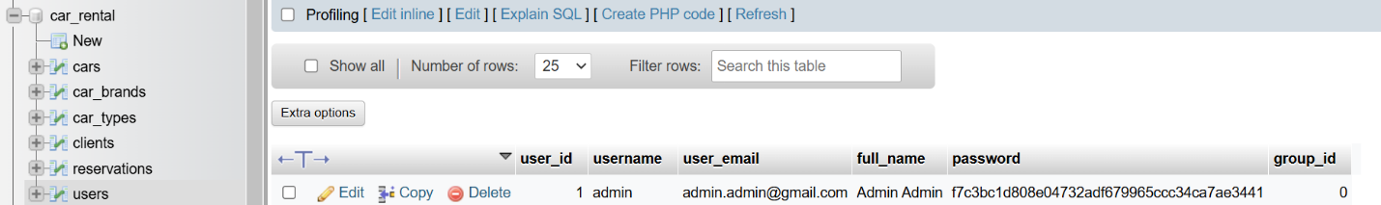

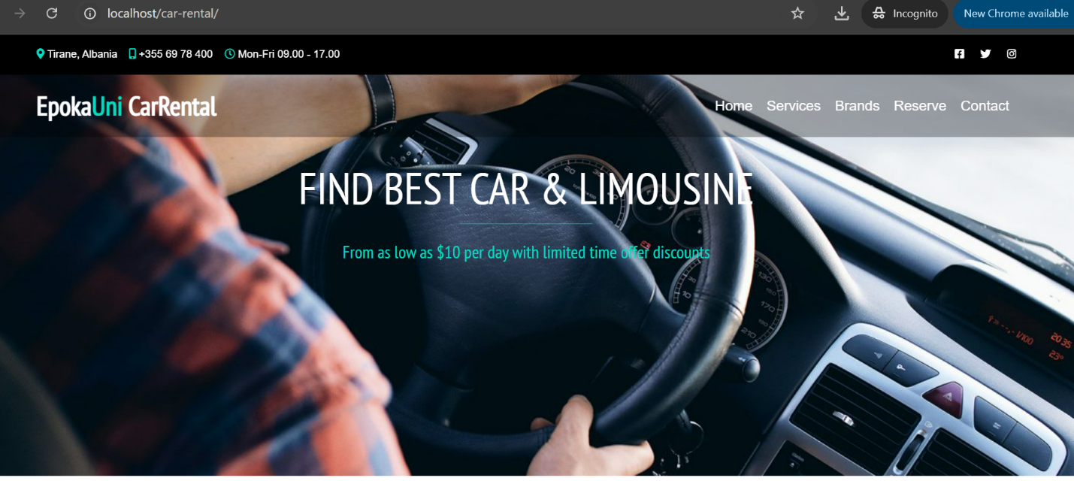
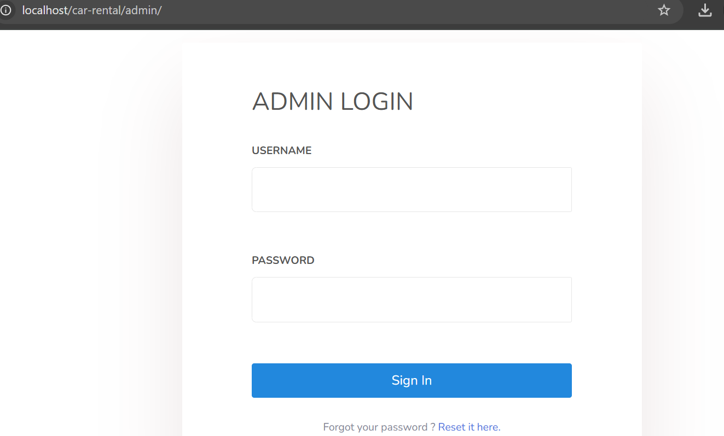
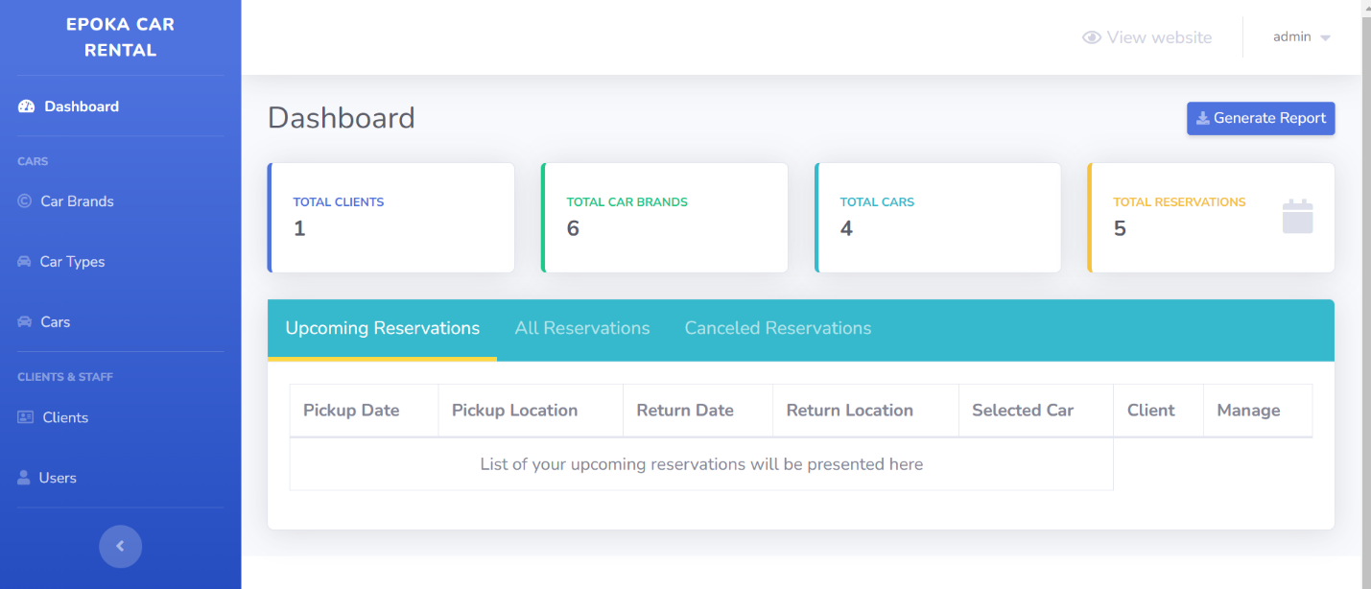
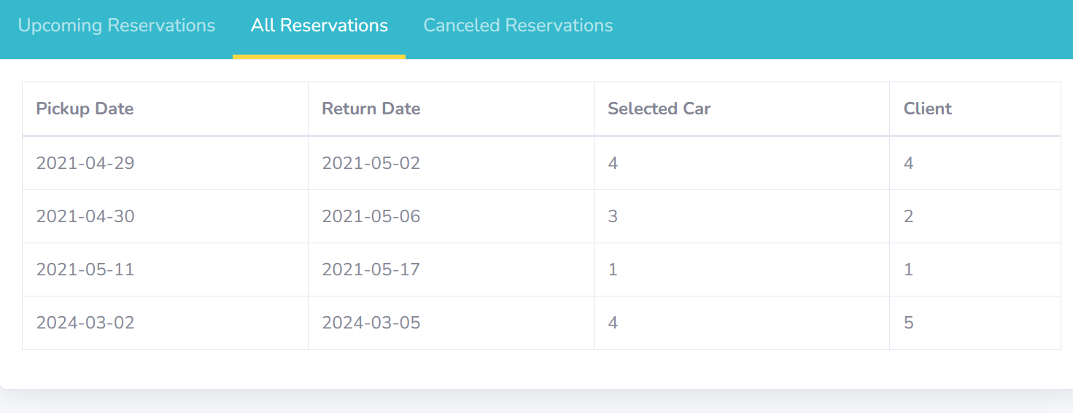
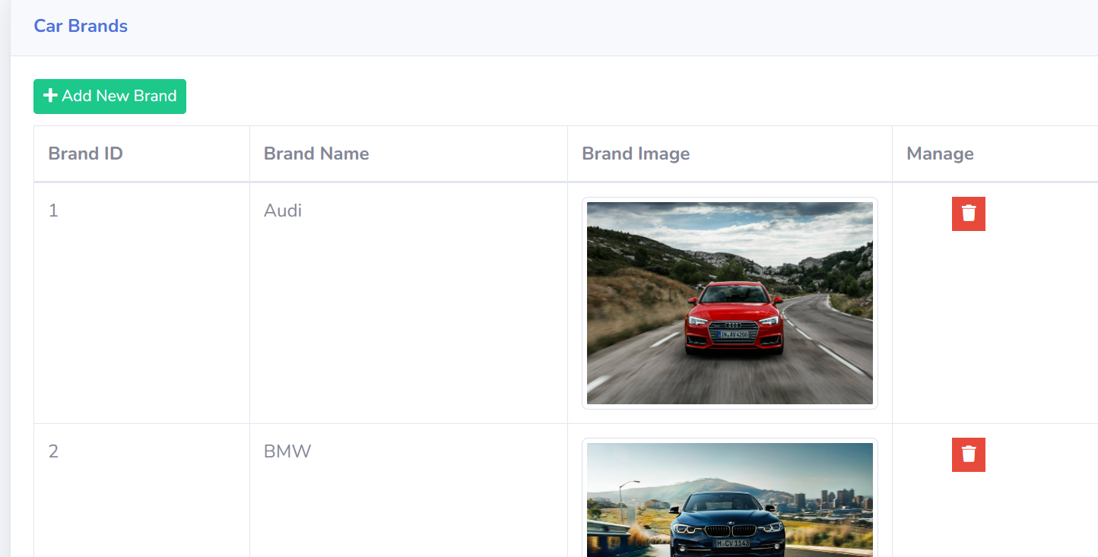
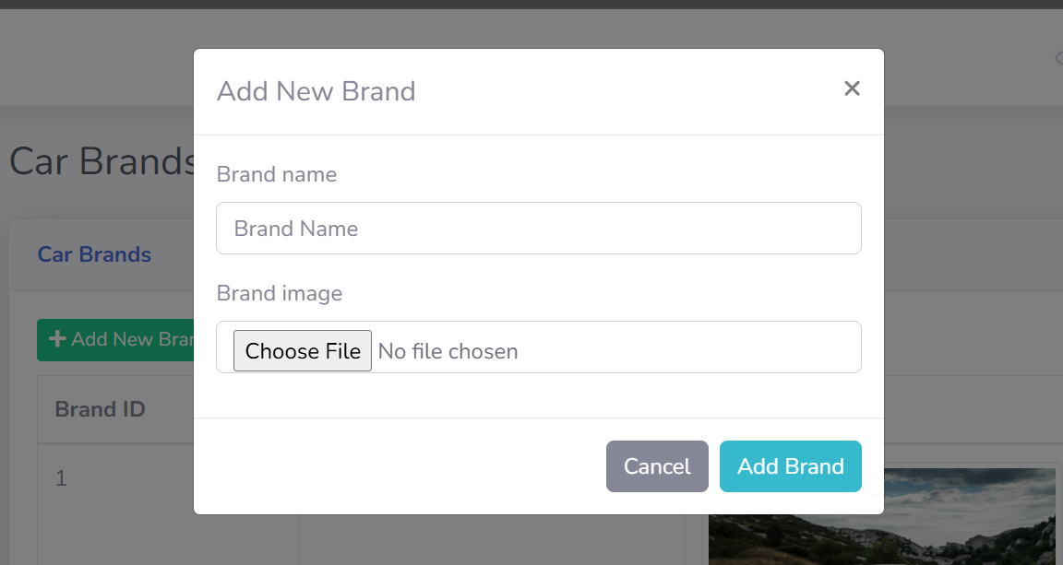
4- Some parts of the source code
<?php
session_start();
include "connect.php";
include "Includes/templates/header.php";
include "Includes/templates/navbar.php";
include "Includes/functions/functions.php";

if (isset($_POST['reserve_car']) && $_SERVER['REQUEST_METHOD'] === 'POST')
{
$_SESSION['pickup_location'] = test_input($_POST['pickup_location']);
$_SESSION['return_location'] = test_input($_POST['return_location']);
$_SESSION['pickup_date'] = test_input($_POST['pickup_date']);
$_SESSION['return_date'] = test_input($_POST['return_date']);
}
?>

<!-- BANNER SECTION -->
<div class = "reserve-banner-section">
<h2>
Reserve your car
</h2>
</div>

<!-- CAR RESERVATION SECTION -->
<section class="car_reservation_section">
<div class="container">
<?php
if(isset($_POST['submit_reservation']) && $_SERVER['REQUEST_METHOD'] === 'POST')
{
$selected_car = $_POST['selected_car'];
$full_name = test_input($_POST['full_name']);
$client_email = test_input($_POST['client_email']);
$client_phonenumber = test_input($_POST['client_phonenumber']);
$pickup_location = $_SESSION['pickup_location'];
$return_location = $_SESSION['return_location'];
$pickup_date = $_SESSION['pickup_date'];
$return_date = $_SESSION['return_date'];

$con->beginTransaction();

try
{
//Getting Client Table Current ID
$stmtgetCurrentClientID = $con->prepare("SELECT AUTO_INCREMENT FROM INFORMATION_SCHEMA.TABLES WHERE TABLE_SCHEMA = 'car_rental' AND TABLE_NAME = 'clients'");

$stmtgetCurrentClientID->execute();
$client_id = $stmtgetCurrentClientID->fetch();

//Inserting Client Details
$stmtClient = $con->prepare("insert into clients(full_name,client_email,client_phone)
values(?,?,?)");
$stmtClient->execute(array($full_name,$client_email,$client_phonenumber));

//Inserting Reservation Details
$stmt_appointment = $con->prepare("insert into reservations(client_id, car_id, pickup_date, return_date, pickup_location, return_location ) values(?, ?, ?, ?, ?, ?)");
$stmt_appointment->execute(array($client_id[0],$selected_car,$pickup_date,$return_date,$pickup_location,$return_location));

echo "<div class = 'alert alert-success'>";
echo "Great! Your reservation has been created successfully.";
echo "</div>";

$con->commit();
}
catch(Exception $e)
{
$con->rollBack();
echo "<div class = 'alert alert-danger'>";
echo $e->getMessage();
echo "</div>";
}

}
elseif (isset($_SESSION['pickup_date']) && isset($_SESSION['return_date']))
{
$pickup_location = $_SESSION['pickup_location'];
$return_location = $_SESSION['return_location'];
$pickup_date = $_SESSION['pickup_date'];
$return_date = $_SESSION['return_date'];

$stmt = $con->prepare("SELECT *
from cars, car_brands, car_types
where cars.brand_id = car_brands.brand_id and cars.type_id = car_types.type_id and
cars.id not in (select car_id
from reservations
where (? between pickup_date and return_date
or ? BETWEEN pickup_date and return_date )
and canceled = 0
)");
$stmt->execute(array($pickup_date, $return_date));
$available_cars = $stmt->fetchAll();
?>
<form action = "reserve.php" method = "POST" id="reservation_second_form" v-on:submit = "checkForm">
<div class = "row" style = "margin-bottom: 20px;">
<div class = "col-md-3 reservation_cards">
<p>
<i class="fas fa-calendar-alt"></i>
<span>Pickup Date : </span><?php echo $_SESSION['pickup_date']; ?>
</p>
</div>
<div class = "col-md-3 reservation_cards">
<p>
<i class="fas fa-calendar-alt"></i>
<span>Return Date : </span><?php echo $_SESSION['return_date']; ?>
</p>
</div>
<div class = "col-md-3 reservation_cards">
<p>
<i class="fas fa-map-marked-alt"></i>
<span>Pickup Location : </span><?php echo $_SESSION['pickup_location']; ?>
</p>
</div>
<div class = "col-md-3 reservation_cards">
<p>
<i class="fas fa-map-marked-alt"></i>
<span>Return Location : </span><?php echo $_SESSION['return_location']; ?>
</p>
</div>
</div>
<div class = "row">
<div class = "col-md-7">
<div class="btn-group-toggle" data-toggle="buttons">
<div class="invalid-feedback" style = "display:block;margin: 10px 0px;font-size: 15px;" v-if="selected_car === null">
Select your car
</div>
<div class="items_tab">
<?php

foreach($available_cars as $car)
{
echo "<div class='itemListElement'>";
echo "<div class = 'item_details'>";
echo "<div>";
echo $car['car_name'];
echo "</div>";
echo "<div class = 'item_select_part'>";
?>
<div class="select_item_bttn">
<label class="item_label btn btn-secondary active">
<input type="radio" class="radio_car_select" name="selected_car" v-model = 'selected_car' value="<?php echo $car['id'] ?>">Select
</label>
</div>
<?php
echo "</div>";
echo "</div>";
echo "</div>";
}
?>
</div>
</div>
</div>
<div class = "col-md-5">
<div class = "client_details">
<div class = "form-group">
<label for="full_name">Full Name</label>
<input type = "text" class = "form-control" placeholder = "John Doe" name = "full_name" v-model = 'full_name'>
<div class="invalid-feedback" style = "display:block" v-if="full_name === null">
Full name is required
</div>
</div>
<div class = "form-group">
<label for="client_email">E-mail</label>
<input type = "email" class = "form-control" name = "client_email" placeholder = "abc@mail.xyz" v-model = 'client_email'>
<div class="invalid-feedback" style = "display:block" v-if="client_email === null">
E-mail is required
</div>
</div>
<div class = "form-group">
<label for="client_phonenumber">Phone numbder</label>
<input type = "text" name = "client_phonenumber" placeholder = "0123456789" class = "form-control" v-model = 'client_phonenumber'>
<div class="invalid-feedback" style = "display:block" v-if="client_phonenumber === null">
Phone number is required
</div>
</div>
<button type="submit" class="btn sbmt-bttn" name = "submit_reservation">Book Instantly</button>
</div>
</div>
</div>
</form>
<?php
}
else
{
?>
<div style = "max-width:500px; margin:auto;">
<div class = "alert alert-warning">
Please, select first pickup and return date.
</div>
<button class = "btn btn-info" style = "display:block;margin:auto">
<a href="./#reserve" style = "color:white">Homepage</a>
</button>
</div>
<?php
}
?>
</div>
</section>

<!-- FOOTER BOTTOM -->

<?php include "Includes/templates/footer.php"; ?>

<script>

new Vue({
el: "#reservation_second_form",
data: {
selected_car : '',
full_name: '',
client_email: '',
client_phonenumber: '',
},
methods:{
checkForm: function(event){
if( this.full_name && this.client_email && this.client_phonenumber)
{
return true;
}

if (!this.full_name)
{
this.full_name = null;
}

if (!this.client_email)
{
this.client_email = null;
}

if (!this.client_phonenumber)
{
this.client_phonenumber = null;
}

if (!this.selected_car)
{
this.selected_car = null;
}

event.preventDefault();
},
}
})

</script>
5- Work schedule (find attached, change the dates according to your project work)
Phase 1: Project Planning and Design (November 1 – November 10, 2024)
Objective: Plan the project structure, finalize system requirements, and design the database schema and system architecture.
- Student 1:
  - Research and gather requirements for the car rental system.
  - Draft the initial system requirements document.
  - Design wireframes for the website interface.
- Student 2:
  - Work with Student 1 to review and finalize the requirements.
  - Begin defining the system’s database schema (tables, relationships, etc.).
  - Set up the project structure for the PHP and MySQL backend.
- Student 3:
  - Draft user stories and scenarios for various user roles (e.g., Admin, Client).
  - Assist with the initial wireframe and UI design review.
  - Research best practices for handling reservations, cars, and payments.
- Student 4:
  - Conduct research on available PHP frameworks and tools that can be used in the project.
  - Start gathering resources (libraries, APIs) for implementing user authentication and car reservation management.
- Student 5:
  - Research and design the system’s administration panel for managing cars, reservations, and clients.
  - Document the overall system design and plan for coding the backend functionality.

Phase 2: Database Development and Backend Setup (November 11 – November 20, 2024)
Objective: Create the database schema, configure the MySQL database, and set up the initial PHP backend.
- Student 1:
  - Develop and finalize the database schema (tables, foreign keys, etc.).
  - Implement basic database CRUD operations for cars, clients, and reservations.
- Student 2:
  - Work on the backend logic for handling car listings (add, update, delete).
  - Implement client registration and login functionality.
  - Start the backend logic for handling reservations and cancellations.
- Student 3:
  - Set up MySQL database on the server and integrate it with the PHP code.
  - Develop APIs for interacting with the database and fetching car data for the frontend.
  - Write SQL queries to fetch, insert, update, and delete reservation data.
- Student 4:
  - Implement basic search and filter functions for cars (by brand, type, availability).
  - Write scripts for handling user sessions and authentication.
  - Test MySQL queries and ensure proper data retrieval.
- Student 5:
  - Work on the admin panel for managing user data, car information, and reservations.
  - Begin designing the interface for managing and viewing reservations from the admin side.
  - Document backend processes for future reference and debugging.

Phase 3: Frontend Development (November 21 – December 5, 2024)
Objective: Develop the user interface (UI) and frontend pages for car browsing, reservation, and user interactions.
- Student 1:
  - Develop the landing page with basic information about the car rental service.
  - Work on the car listing page that displays available cars based on search and filter criteria.
  - Integrate dynamic content on the homepage (e.g., featured cars, special offers).
- Student 2:
  - Work on the client registration page and login system.
  - Develop the reservation form where users can select pickup and return dates, locations, and car types.
  - Implement error handling and form validation on the frontend.
- Student 3:
  - Design and implement the car details page, showing more detailed information when a car is clicked.
  - Integrate dynamic content into the frontend by fetching car data from the database.
  - Test UI responsiveness and ensure compatibility across browsers and devices.
- Student 4:
  - Develop the reservation confirmation page.
  - Implement user-friendly features such as date pickers, car selection dropdowns, etc.
  - Ensure frontend security and prevent invalid data from being sent to the backend.
- Student 5:
  - Implement the admin panel's frontend, including views for managing reservations, cars, and users.
  - Create a user dashboard where users can view past and upcoming reservations.
  - Test the admin functionality to ensure smooth navigation and data management.

Phase 4: Integration and Testing (December 6 – December 20, 2024)
Objective: Integrate the frontend and backend, and conduct comprehensive testing of the system.
- Student 1:
  - Integrate frontend with backend logic for creating and viewing reservations.
  - Work with the testing team to create test cases for car listings and user reservations.
  - Test the car search functionality and fix any bugs related to data fetching.
- Student 2:
  - Integrate client registration and login functionality with the backend.
  - Ensure that data entered in forms is correctly passed to the backend (e.g., reservation forms).
  - Test the reservation and cancellation processes, making sure the database updates accordingly.
- Student 3:
  - Test the payment system (if integrated) and ensure that payment processing works correctly.
  - Verify user roles (Admin and Client) and ensure proper access control is in place.
  - Work on fixing any bugs found during the integration process and provide suggestions for improvements.
- Student 4:
  - Conduct cross-browser and mobile testing to ensure the website is responsive.
  - Test user interface elements, such as forms, buttons, and search filters.
  - Ensure that the database functions (insert, update, delete) work seamlessly with the frontend.
- Student 5:
  - Test the admin panel functionalities, ensuring that admins can manage car inventory, client data, and reservations.
  - Conduct stress tests to ensure the system can handle a high number of concurrent reservations.
  - Implement logging and error tracking to monitor issues during testing.

Phase 5: Deployment and Final Presentation (December 21, 2024 – January 10, 2025)
Objective: Deploy the car rental system on a production server, finalize documentation, and prepare for presentation.
- Student 1:
  - Deploy the database and backend code to the production server.
  - Work on finalizing the project documentation (system overview, database schema, API documentation).
- Student 2:
  - Deploy the frontend code to the production server.
  - Finalize and test all user interface pages on the live server.
- Student 3:
  - Ensure proper security measures (SSL, secure login) are implemented for the live environment.
  - Test the full reservation process on the production server to ensure the system is fully functional.
- Student 4:
  - Finalize and update all test cases and results documentation.
  - Conduct a final round of user testing with real users to gather feedback.
- Student 5:
  - Prepare the final presentation and demo of the car rental system.
  - Update the admin panel with any final improvements based on user feedback.

Phase 6: Project Handover and Review (January 11 – January 20, 2025)
Objective: Complete the final project review, fix any last-minute issues, and hand over the project to the stakeholders.
- Student 1:
  - Prepare the final project report and review the entire development process.
  - Handover the codebase, database schema, and documentation.
- Student 2:
  - Ensure all features are working and make any last-minute fixes.
  - Assist with the project handover, ensuring all components are included in the final deliverables.
- Student 3:
  - Present the final project during the demonstration and address any questions.
  - Provide any necessary post-project support or bug fixes.
- Student 4:
  - Assist with preparing the final presentation.
  - Address any final issues or improvements needed.
- Student 5:
  - Assist with project handover and ensure all necessary documentation is included.
  - Review the final deployment on the production server and ensure everything is in place for a successful handover.

